SMART RESTAURANT WITH E-MENU CARD

AIM:
The aim of the project is to develop Menu Recommender to enhance customer service and improve restaurant industry.

EXISTING METHOD:

Conventional systems like restaurant services such as making reservations, processing orders, and delivering meals generally require waiters to input customer information and then transmit the orders to kitchen for meal preparation. When the customer pays the bill, the amount due is calculated by the cashier.

Electronic POS Terminals like the servers/waiters generally take the order from the customer and head onto a terminal, where they can feed the order into a computer. The order can then be transmitted to the kitchen automatically via the terminal through a network, or it may even be delivered manually by the server to the kitchen.

PROPOSED METHOD:
The e-Menu provides additional information about menu items and drinks than a traditional paper menu. With interactive pictures it gives additional information about the food item. Here we require a mobile with android application. When the customer gets login into the app, he can find a wide variety and colorful images of all the menu items which will be helpful in selecting the exact item which gives the customer a great satisfaction.

LOGIN DEVICE:
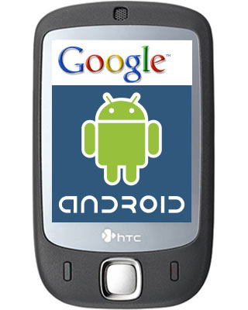

KITCHEN/ADMIN SECTION:

MICRO CONTROLLER (AT89S52)
LCD DISPLAY
(16*2 LINES)
POWER SUPPLY
BLUETOOTH MODULE
PC

BLUETOOTH TECHNOLOGY:
Bluetooth was selected as our way of communicating PDA/Mobile with a central system. The reason Bluetooth was selected over Bluetooth for various reasons. First of all, Bluetooth security is less complex and more stable than that of Wi-Fi. Bluetooth manages a security measure of only permitting certain selected devices to interact with them; Wi-Fi in the other hand establishes a WEP key that has been known to be cracked. Another reason that Bluetooth was selected over Wi-Fi is that Bluetooth has a shorter range of signal emission than Wi-Fi. This is a pro because the shorter the range the less the amount intruders that will try to infiltrate your home system.
Android:
Android is a software stack for mobile devices that includes an operating system, middleware and key applications. The Android SDK provides the tools and APIs necessary to begin developing applications on the Android platform using the Java programming language.

SOFTWARE : Embedded ‘C’, android .apk.
TOOLS : Keil uVision3, ISP.
TARGET DEVICE : AT89S52, Smart Android Mobile.
APPLICATIONS : Restaurants, Hotels.
ADVANTAGES : Can have a clear idea of all items, Overcomes errors in order taking.

